2 Hours 30 Minutes
I think me having a grasp on classes helped with this assignment.
It did take me a tiny bit to figure out what the promt was again…
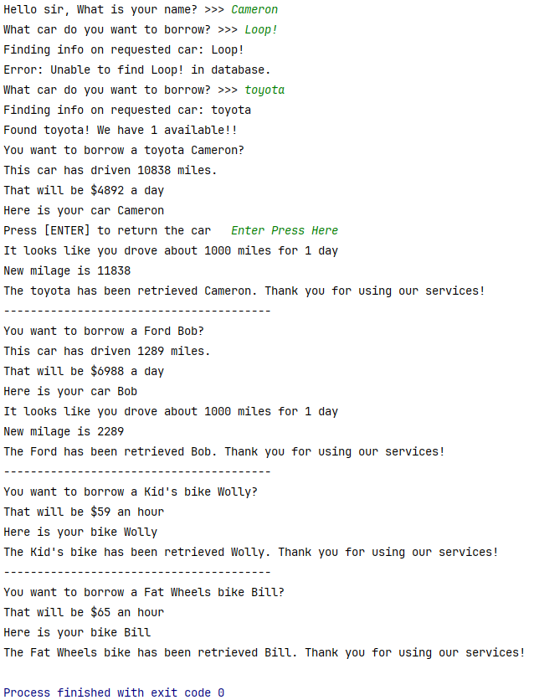
Output:

